NAME: _______________________Date:_______________ |  |  |  |  |  |  |  |  |  |  |  |  |  |  |  |  |  |  |  |  | Comprehensive Examination 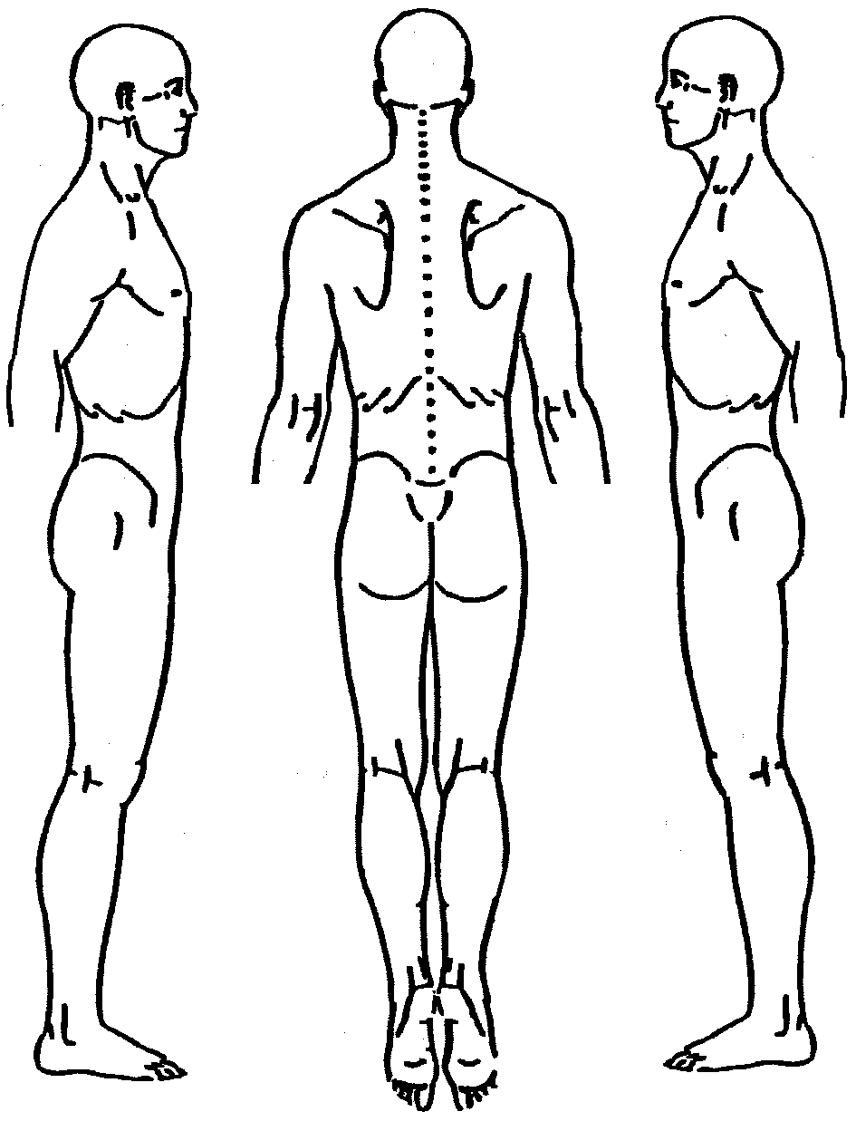 Rear-End | Head-On | Side Impact L R
Male / Female DOB: ______/______/______ AGE: ______
Ht: ______ ft ______ in WT: __________ Lbs.
Work: ___________________________________________
Size: Normal Underweight Corpulent
Demeanor: A/O/C Gait: POS NEG
Limp Favors: L R Antalgic Tilt: L R
BP ______/______ Pulse_______
Chief Complaints
1 |  |  |  |  |  |  |  |  |  |  |  | 5
2 |  |  |  |  |  |  |  |  |  |  |  | 6
3 |  |  |  |  |  |  |  |  |  |  |  | 7
4 |  |  |  |  |  |  |  |  |  |  |  | 8
Cranial: Gross Norm / Comp Norm
Neuro Reflexes
Upper Extremities
Biceps L | R
Brachial L | R
Triceps L | R
Lower Extremities
Patellar L | R
Achilles L | R
Babinsk’s L | R
Rule Out:
Disc / Fx / CHT / Sprain
Pathology / TOS
R/O Notes:____________________
__________________________________________________________
 | ROM Cervical |  |  |  |  |  |  |  |  | ROM Dorsal |  |  |  |  | ROM Lumbar |  |  |  |  |  |  | ROM Shoulder
 | R | N | p s |  |  |  |  |  |  | R |  |  | N | p s | R |  |  | N |  | p s |  | Left |  | p | s | Right |  |  |  | p | s
FLX |  | 50 |  |  |  |  |  |  |  |  |  |  | 90 |  |  |  |  | 60 |  |  | FLX | 180 |  |  |  | 180
EXT |  | 60 |  |  |  |  |  |  |  |  |  |  | 25 |  |  |  |  | 25 |  |  | EXT | 50 |  |  |  | 50
LLF |  | 45 |  |  |  |  |  |  |  |  |  |  | 25 |  |  |  |  | 25 |  |  | AB | 180 |  |  |  | 180
RLF |  | 45 |  |  |  |  |  |  |  |  |  |  | 25 |  |  |  |  | 25 |  |  | AD | 50 |  |  |  | 50
LRO |  | 80 |  |  |  |  |  |  |  |  |  |  | 25 |  |  |  |  | 45 |  |  | E Rot | 90 |  |  |  | 90
RRO |  | 80 |  |  |  |  |  |  |  |  |  |  | 25 |  |  |  |  | 45 |  |  | I Rot | 90 |  |  |  | 90
P: 1 = Mild; 2 = Moderate; 3 = Significant *S: Muscle spasms reported by the patient |  |  |  |  |  |  |  |  |  |  |  |  |  |  |  |  |  |  |  |  |  | All Normal All Normal
ORTHOPEDICS |  |  |  |  |  |  |  |  |  |  | PALPATION |  |  |  |  |  |  |  | Neuro Dermatome |  |  | UE Muscle Testing |  |  |  |  | L |  | R
Ortho Cervical |  |  |  | L |  |  | R |  |  |  | Ortho Cervical |  |  |  |  | L | R |  |  |  |  | Mid Deltoid (C5)
Cervical Distraction |  |  |  |  |  |  |  |  |  |  | Cervical Region |  |  |  |  |  |  |  | Upper Extremities  All Normal  or  Left Right  Increased:  _______________  Decreased:  _______________  Lower Extremities  All Normal  or  Left Right  Increased:  _______________  Decreased:  _______________ |  |  | Biceps (C5-6)
Foraminal Compression |  |  |  |  |  |  |  |  |  |  | Trapezius |  |  |  |  |  |  |  |  |  |  | Wrist Extensors (C6)
Jackson’s Compression |  |  |  |  |  |  |  |  |  |  | Scalenes |  |  |  |  |  |  |  |  |  |  | Triceps (C7)
Valsalva’ Test |  |  |  |  |  |  |  |  |  |  | SCM |  |  |  |  |  |  |  |  |  |  | Wrist Flexors (C7)
Soto Hall |  |  |  |  |  |  |  |  |  |  | Suboccipitals |  |  |  |  |  |  |  |  |  |  | Finger Extensors (C7)
Shoulder Depression |  |  |  |  |  |  |  |  |  |  | Levator Scapula |  |  |  |  |  |  |  |  |  |  | Finger Flexors (C8)
Lumbar Tests |  |  |  | L |  |  | R |  |  |  | Lumbar Tests |  |  |  |  | L | R |  |  |  |  | Finger ABD/ADD (T1)
Bechterew’s (single) |  |  |  |  |  |  |  |  |  |  | Lumbar Region |  |  |  |  |  |  |  |  |  |  | LE Muscle Testing |  |  |  |  | L |  | R
Bechterew’s (double) |  |  |  |  |  |  |  |  |  |  | Erectors |  |  |  |  |  |  |  |  |  |  | Iliopsoas (T1,2-L3)
Straight Leg Raise |  |  |  |  |  |  |  |  |  |  | QL |  |  |  |  |  |  |  |  |  |  | Quadriceps (L2-4)
LBP | Radicular |  |  |  |  |  |  |  |  |  |  | Lumbo-Sacral |  |  |  |  |  |  |  |  |  |  | Adductors (L2-4)
Braggard’s |  |  |  |  |  |  |  |  |  |  | Iliopsoas |  |  |  |  |  |  |  |  |  |  | Tibialis Anterior (L4)
Fajersztajn’s |  |  |  |  |  |  |  |  |  |  | Iliocostalis |  |  |  |  |  |  |  |  |  |  | Gluteus Medius (L5)
Kemp’s |  |  |  |  |  |  |  |  |  |  | Multifidi |  |  |  |  |  |  |  |  |  |  | Ext Hallucis Long (L5)
LBP | Radicular |  |  |  |  |  |  |  |  |  |  | Longissimus |  |  |  |  |  |  |  |  |  |  | Hamstrings (L5-S1)
Milgram’s |  |  |  |  |  |  |  |  |  |  |  |  |  |  |  |  |  |  |  |  |  | Peroneous Longus (S1)
Fabere Patrick |  |  |  |  |  |  |  |  |  |  | Leg Length |  |  |  |  |  |  |  |  |  |  | Gluteus Maximus (S1)
Lasegue |  |  |  |  |  |  |  |  |  |  | Left > Right |  |  |  |  |  |  |  |  |  |  | Gastrocnemius/Soleus
Derefield |  |  |  |  |  |  |  |  |  |  | Right > Left |  |  |  |  |  |  |  |  |  |  | Foot Flexors
Lumbar Distraction |  |  |  |  |  |  |  |  |  |  | Equal |  |  |  |  |  |  |  |  |  |  | Foot Extensors
Valsalva’s |  |  |  |  |  |  |  |  |  |  | Inches:________________
Goldthwaits’ S L

 |  |  | ORTHOPEDICS |  |  | PALPATION
Neuro Cranial Nerves | N | A | Ortho Thoracic | L | R | Ortho Thoracic | L | R
Olfactory (Smell) |  |  | Schepelmann’s |  |  | Thoracic Region
Optic (Accom & Light) |  |  | Concave | Convex |  |  | Costotransverse Findings:
Oculomotor (Eye) |  |  | Sternal Compression |  |  | Edema: __________ Swelling:_________
Trigeminal |  |  | Allen (R or U artery) |  |  | Pain: __________ Tender:__________
Trochlear (Eye) |  |  | Wright (Hyperabduct syn) |  |  | Costovertebral Findings:
Abducens (Eye) |  |  | Adson (SA Syndrome) |  |  | Edema: __________ Swelling:_________
Facial Sensation |  |  | Eden (Costoclav Syn) |  |  | Pain: __________ Tender:__________
Acoustic Whisper |  |  | Hostage Test |  |  | Erector SP
Glossopharyn Gag |  |  | Halstead Test |  |  | Trapezius
Vagus Voice |  |  | Notes: |  |  | Levator
Spinal Accessory - Shrug |  |  |  |  |  | Rhomboids
Hypoglossal (tongue in cheek) |  |  |  |  |  | Semispinalis
Neuro Cerebellar | L | R | Ortho TMJ | L | R | Ortho TMJ | L | R
Finger to Nose |  |  | Masseter |  |  | Clicking
Heel to Shin |  |  | Temporalis |  |  | Popping
Postural Evaluation | L | R | Auscultation |  |  | Grinding
Heel Walk |  |  | Head: Normocephalic Laceration/Scars |  |  | Tenderness
Toe Walk |  |  | Laceration/Scars: F O M C |  |  | Chin
Head Tilt |  |  | Cervical Spine Muscle Test | L | R | Pulses | L | R
Trendelenburg’s |  |  | Extension |  |  | Femoral
High Shoulder |  |  | Flexion |  |  | Popliteal
High Iliac Crest |  |  | Lateral Bending |  |  | Posterior Tibial
Notes: |  |  | Rotation |  |  | Dorsal Pedis
 |  |  | Trunk Flexors |  |  | Radial
 |  |  | Trunk Extensors |  |  | Brachial

Additional ROM Studies ( ) Visual *( ) Goniometer ( ) Inclinometer
Wrist LT | F (60) | E(60) | Radial Dev (20) |  | Ulnar Dev (30)
Wrist RT | F (60) | E(60) | Radial Dev (20) |  | Ulnar Dev (30)
Hip LT | F (100) | E(20) | ABD(40) | ADD(20) | IR(40) |  | ER(45)
Hip RT | F (100) | E(20) | ABD(40) | ADD(20) | IR(40) |  | ER(45)
Elbow LT | F (140) | E(0) | Pronation(80) |  | Supination (80)
Elbow RT | F (140) | E(0) | Pronation(80) |  | Supination (80)
Knee LT | F (150) | E (0) | Internal Rotation (40) |  | External Rotation (45)
Knee RT | F (150) | E (0) | Internal Rotation (40) |  | External Rotation (45)
Ankle/Ft LT | DF (20) | PF (20) | Inversion (30) |  | Eversion (20) | AB (20) |  | AD (10)
Ankle/Ft RT | DF (20) | PF (20) | Inversion (30) |  | Eversion (20) | AB (20) |  | AD (10)

Additional Notes

ORTHOPEDICS |  |  | PALPATION
Sacroiliac Tests | L | R | Sacroiliac Tests | L | R
Nachlas |  |  | Coccyx
Ely’s Sign |  |  | Gluteus Maximus
Ely’s Test |  |  | Gluteus Minimus
Hibb’s |  |  | Piriformis
Yeoman’s |  |  | Sacroiliac
Gaenslen’s |  |  | Iliopsoas
Sciatic Notch |  |  | Sacro Tubercle
Thomas Test |  |  | Sacral Tuberous
Knee Tests | L | R | Knee Tests | L | R
Valgus ADD Stress |  |  | TibioFemor
Varus ABD Stress |  |  | Popliteal Fossa
Apprehension |  |  | Fibular Head
Drawers A / P |  |  | Tibial Tuberocity
McMurray’s |  |  | Infrapatellar Tendon
Appley’s Comp |  |  | Bruises: L: A P L M
Appley’s Dist |  |  | R: A P L M
Knee Effusion |  |  | Vastus Lateralis
Patellar Grind |  |  | Adductors
Lachman’s
Ortho Foot | L | R | Ortho Foot | L | R
Anterior Drawer |  |  | Digits: 1 2 3 4 5
Posterior Drawer |  |  | Cuniforms
Eversion Stress |  |  | Malleolus
Inversion Stress |  |  | Calcaneous
Arch Supinated |  |  | Cuboid
Arch Pronated |  |  | Talus
Notes: |  |  | Plantar Fascia
 |  |  | Achilles’ Tendon

ORTHOPEDICS |  |  | PALPATION
Ortho Shoulder | L | R | Ortho Shoulder | L | R
Appley’s |  |  | Teres Major
Yergason’s |  |  | Teres Minor
Dawbarn’s |  |  | Supraspinatus
Codman’s Sign |  |  | Infraspinatus
Apprehension |  |  | Deltoid
Notes: |  |  | A/C Joint
 |  |  | Bicipital Tendon
 |  |  | Acromial Process
 |  |  | Coracoid Process
 |  |  | Bursa
 |  |  | Bicipital Groove
Ortho Elbow | L | R | Ortho Elbow | L | R
Valgus ADD Stress |  |  | Extensors
Varus ABD Stress |  |  | Flexors
Cozen’s |  |  | Olecranon
Mill’s |  |  | Triceps Tendon
Notes: |  |  | Radial-Humeral
 |  |  | Ulnar-Humeral
Ortho Wrist | L | R | Ortho Wrist | L | R
Tinel’s |  |  | Snuff Box
Phalen’s |  |  | Navicular
Prayer (Rev Phalen’s) |  |  | Scaphoid
Notes: |  |  | Anterior / Posterior
 |  |  | Medial / Lateral
 |  |  | Distal MCP
 |  |  | Proximal MCP
 |  |  | Interphalangeal

Additional Notes

